Q1
Step01: According to source code, we can use Exploiting Format String
Step02: The buffer is 1024 long, so I inputted something that longer than 1024
Answer:
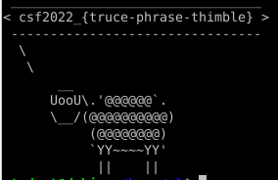

Q2
Step01: Overflow the buffer to change “changeme”
Answer:
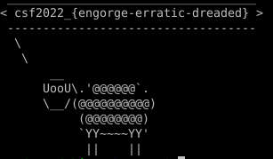

Q3
Step01: Finding the address of function secret
Step02: Overflow the buffer to change the return address
Answer:
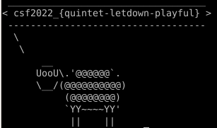

Q4
Solution1: Input a buffer that longer than 1024 to overwrite the fp
Finding the address of function secret
Try to write payload
Neither print nor sys.stdout.buffer.write work in the hacklabVM, so I tried them in kaliVM
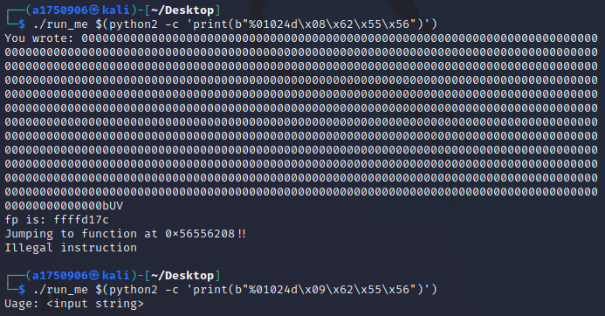
In kaliVM, we cannot write \x09 into memory either while writing other things like \x08 is fine.

Solution2: Write the length of output to specific memory address using hhn
Finding the address of function secret, function lose and fp
0xffffd38c contains value 0x5655623f which is the address of lose, so this is fp
First, I tried this in gdb, it successfully changed the value of fp to 0x56556209, but the cat command is denied
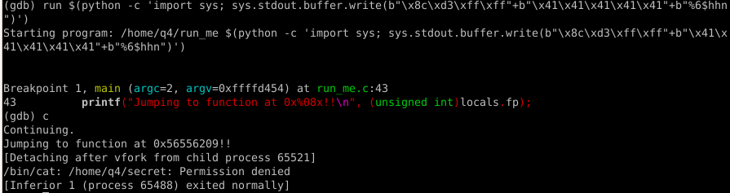
But it still cannot be adopted out of gdb

Q5
Step01: Creating a symbolic link of secret in q5 on Desktop, the name is secet
Step02: Creating a symbolic link of run_me in q5 on Desktop
Step03: Executing run_me on Desktop
Answer:
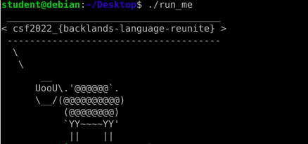

Q6
Step01: Setting Q6_SECRET_CODE
Answer:
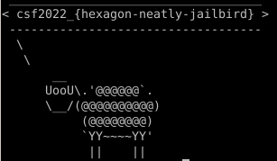

Q7
a)
An egress filter protects computer from dangerous and unnecessary connections.
Disrupt malware
An egress filter blocks malware from connecting its server. And the filter will also protect data if a malware exports them and then tries to send data to hackers.
Block unwanted services
Using egress filter is a good way to set supervision on a target computer since it can block user out from specific ports and protocols. It can also reject the request to certain IP range.
Stop contributing to attacks
Egress filter prevents a computer from being a part of network attacks, malware hosting, spamming, and botnets. By this way, egress filter helps provide a stable and safe internet environment.
Greater awareness of network traffic
An egress filter provides more information of your computer’s both authorized and unauthorized activities. User can obtain record to better control their machine.

b)
The 2016 Dyn attack mainly using TCP SYN floods against port 53 of Dyn’s servers, which efficiently consumes servers’ resource by adding random subdomains.
Hackers can also use ports 80 or 443 to set up an RDP tunnel with their servers. By analysis the network traffic may discover the connection is entirely not HTTP or HTTPS, but some intentionally disguised secret communications.

Q8
Step01: Finding the return address
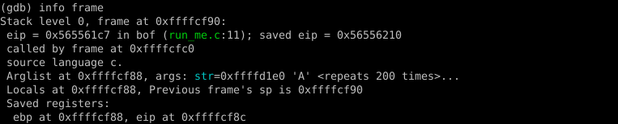
Step02: Deciding the length of payload
ffffcf8c-ffffcb80 = 1036
Step03: run in gdb with %0xxd
Not working, so I tried sys.stdout.buffer.write
Successfully changed the return address to somewhere in NOPSLED
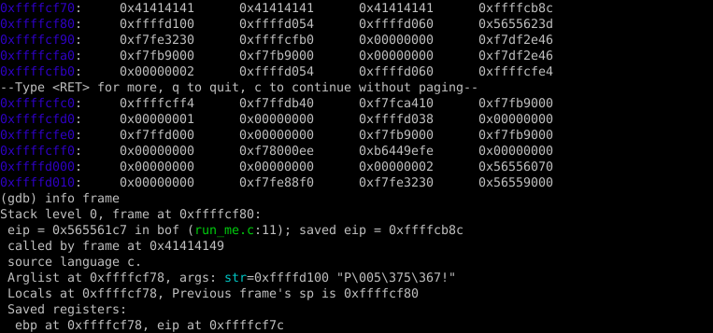
Step04: Continue in gdb, and I got the shell
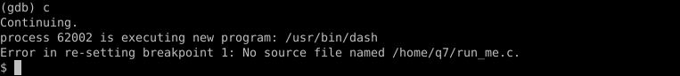
Step05: Run in shell, not working

Q9
Step01: According to the source code, target is under the buffer in stack, so my solution is overwriting it with the length of input
Step02: Finding the address of target
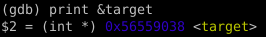
Step03: Finding the offset of my input, the result is 4
Step04: Writing payload
Answer:
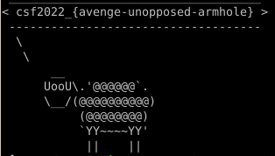
Step05: Payload of bouns
Answer:

